Project Development Phase
Model Performance Test

Date | 10 February 2025
Team ID | SWTID-2026-6670
Project Name | Implement Client Script & UI Policy (Incident)
Maximum Marks | 10 Marks

Model Performance Testing:
Project team shall fill the following information in model performance testing template.
S.No. | Parameter | Values | Screenshot
 | Metrics | Regression Model:  MAE, MSE, RMSE, R2 score - Not applicable (no numeric prediction)  Classification Model (block / allow outcomes of the validation rules):  Confusion Matrix - Should block & blocked: 2 (TC-005, TC-008); Should block & allowed: 0; Should allow & allowed: 3 (TC-006, TC-007, TC-009); Should allow & blocked: 0  Accuracy Score - 100% (5 / 5 gate cases); all 9 test cases passed  Classification Report - Precision 1.00, Recall 1.00, F1-score 1.00 | 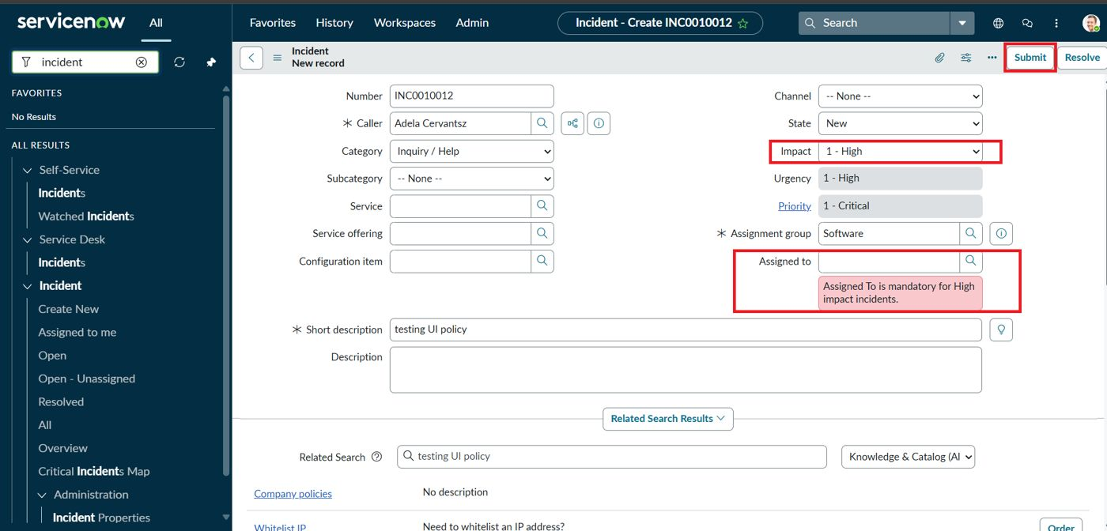
 | Tune the Model | Hyperparameter Tuning - Not applicable (rule-based; no trainable parameters)  Validation Method - Manual UAT with positive and negative scenarios (TC-001 to TC-009) on a ServiceNow developer instance

